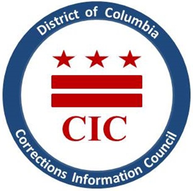
Update on Corrections Information Council
Operating Status and Modified Schedule during COVID-19 Emergency

As the nation continues to learn more about the Coronavirus (COVID-19) and its effects, the CIC is committed to prioritizing the health and safety of the incarcerated residents of the District of Columbia. Our agency remains open and available for calls, emails, and letters with concerns. The District Government will continue to operate on a modified schedule, through April 27, 2020.
Since beginning the modified schedule the CIC remains available for local issues and concerns. Last week CIC staff visited Hope Village in response to complaints from community members and residents about inadequate supplies. Please view the CIC’s statement on Hope Village HERE. We are updating our site regularly to reflect news on the conditions of confinement within the BOP and the DOC in regards to the Coronavirus.
As of today, April 1, 2020, there are 29 confirmed inmate cases of COVID-19 within the Bureau of Prisons (BOP), and 30 confirmed staff cases. The DC Department of Corrections (DOC) has reported 5 confirmed cases of COVID-19. Please visit our website for up to date information as we continue to support one another during this time.
Thank you and stay healthy.

