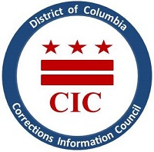
NOTICE
OPEN MEETING*
Who: Corrections Information Council (CIC)
When: Thursday, July 25, 2019
Time: 6pm – 7:30pm
Location: 1400 I St NW, Suite 400 Washington, DC 20009,
Contact Information: Sheila Walker (202) 478-9211
*This meeting is open to the public. The second half of the meeting will be closed to discuss a board related matter. Please refer to D.C. Code § 2-575 (b) (2019),
https://code.dccouncil.us/dc/council/code/sections/2-575.html
Agenda:
- Roll Call
- Minutes from May’s board meeting
- Agency Updates
- Closed portion

